Ningbo Longwell Electric Technology CO.,LTD
NO.100, Ditang District ,Yuyao,Zhejiang Province,China 315400
Phone 86 574 6218 9863
Fax 86 574 6218 9863
sales@zjlongwell.com
www.longwellfans.com

Model No.: | LWAA4E500S-5MYB-19-00
Version Number: | A0
Make : | YE
Review : | Guo
Approvd : | Zhang
Date： | 20260731

Version number | Notes Remarks | Reason content | Revised by | Date



Nominal Data

Project1 | Unit | Rating
Nominal Voltage : | [VAC] | 220
Voltage Range : | [VAC] | 198~242
Frequency : | [Hz] | 50
Speed : | [rpm] | 1380
Current : | [A] | 2.1
Power input : | [W] | 450
Air flow (Max) : | [m3/h] | 7468
Air flow (Max) : | [CFM] | 4393
Capacitor : | μF | 15
Noise level (LpA) : | dB(A) | 70
Max.ambient Temp : | ℃ | 60
Min.ambient Temp : | ℃ | -30
Insulation Class : |  | Class F
Protection Type : |  | IP54
Work system : |  | S1

Technical Features

Service environment | Operating temperature：-30~60℃；Operating humidity：0 ~ 85 % RH  Storing temperature：-40 ~ 80℃；Storing humidity：0 ~ 95 % RH  Applicable altitude range：＜1000m
Life Expectance | 30,000Hours(L10)，At 40℃ room, humidity 15%~65%RH.
Balancing | According to JB/T 9101-1999 requirements G6.3
Vibration of the fan | Test method accord with JB/T 8689
Installation method | Horizontal or vertical installation
Material | Cold-rolled sheet ( Impeller )
Bearing | Maintenance-free deep groove ball bearings
Production Reference standard | GB12350《Safety requirements of small power motors》  JB/T10562 《 Technical specification for general purposes axial fans》  EN60335-1《Household and similar electrical appliances-safety》  ISO5801-1997《Industrial fans-performance testing using standardized airways》  GB/T2888《Methods of Noise Measurement for Fans Blowers Compressors and Roots Blowers》
Certification | CE
Environmental protection | RoHS、Reach
Weight | /

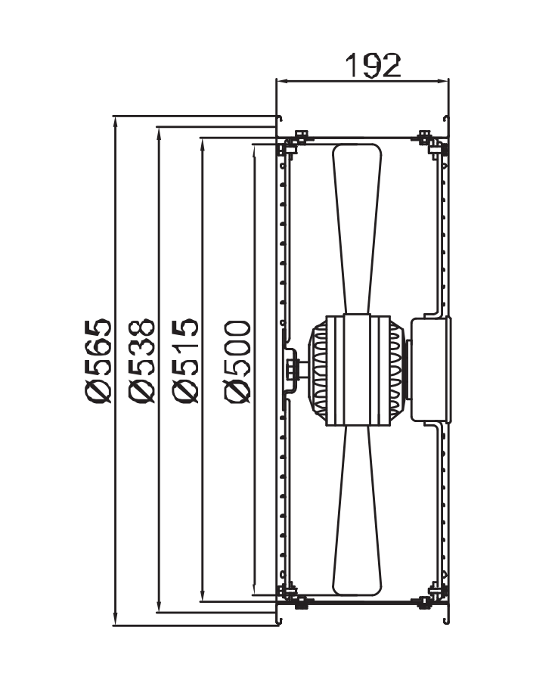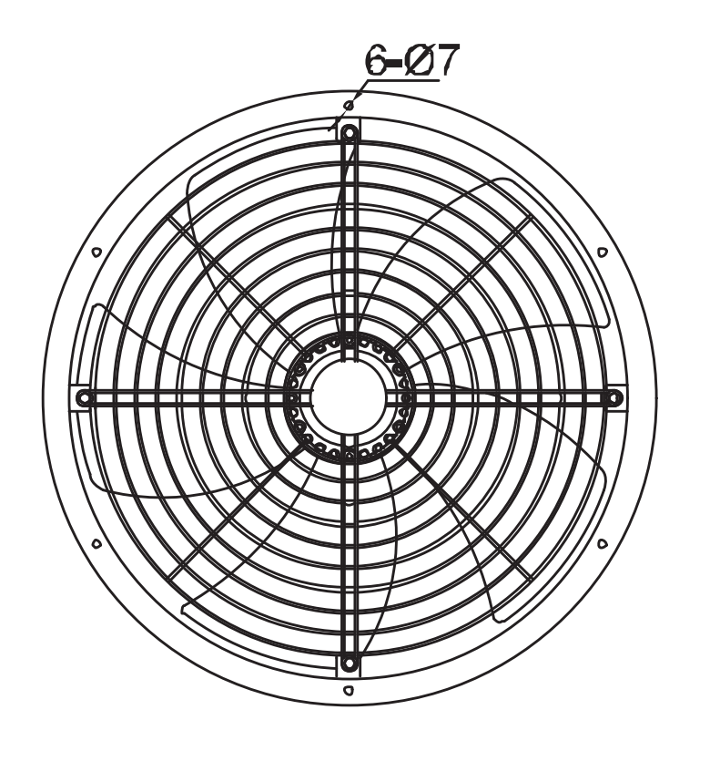
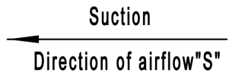
Product Drawing

Wiring Diagram

Label

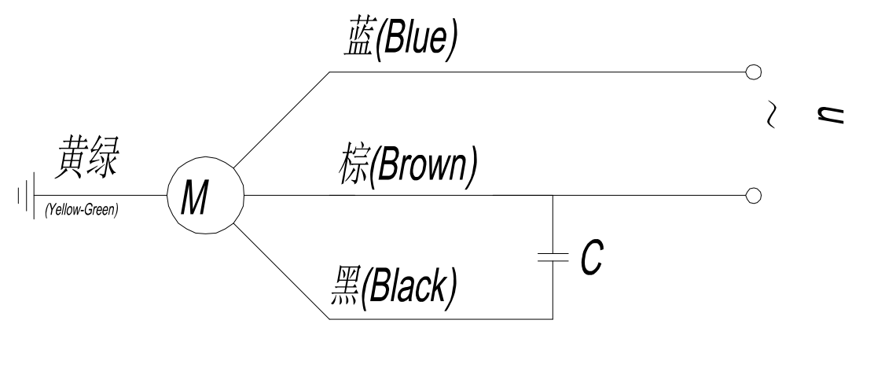

Confirm by sales team when placing sample order or bulk order

Charts :Air Flow (P-Q)

电流≦ mA不能用于***，上电顺序要求

Confirm by sales team when placing sample order or bulk order
Label

Warning:

1.The fan and motor must be used within the prescribed scope of temperature and humidity otherwise it will cause an unexpected damage.
2. Fan is not set wrong connection protection，Provide the right voltage and line sequence according to the nameplate otherwise it will damage the product.
3. Wiring depends on the wiring diagram and please connect the earth ground if required. We don't suggest to use the extension cord .Any wrong connection may cause the damage of the fan.
4. Be careful when moving the fan and do not take the blades as a handle because it will cause the distortion and chatter.
5. Connect the thermostat if required otherwise it would damage the motor because of the over temperature.
6. The length of the mounting screws shall not exceed the requirement, otherwise the fan will be damaged.
7. Do not disassemble the fan arbitrarily. It may hurt the capacity of water tightness and dynamic balance or cause other serious problems.
8. The over current protector is necessary in case the damage from the over current.
9. Install the fan as required, any other installing direction would affect the service life of the product.
10. The fan with inlet ring should be installed follow the requirements or it will affect the performance.
11. Users should use the standard cable when install the fan otherwise it will affect the water tightness.
12. The fan should keep away from the children especially the blade and electric parts .And the children are not allowed to operate the fan alone.
13. Do not connect the white signal cable directly to the red signal cable or the external DC power supply. Otherwise, the fan may be damaged.T
14.Please do not perform extraction and insertion of the connector under revolution irrespective of power on and power on and power off , and the fan should not touch or move when running.

15. Do not lift the fan wire when taking the fan, and do not impact the bearing during the handling process.
16. The version change may not be notified, please ask our company for the latest version when necessary.

17.Please be informed that we are not responsible for any damage or accidents caused by violating above rules to install and operate the fan.

Approval
Product Data Confirm :

DATE :

CUSTOMER SIGNATURE:

CUSTOMER APPROVAL

