Ningbo Longwell Electric Technology CO.,LTD
NO.100, Ditang District ,Yuyao,Zhejiang Province,China 315400
Phone 86 574 6218 9863
Fax 86 574 6218 9863
sales@zjlongwell.com
www.longwellfans.com

Model No.: | LWAA12038SH-35-00
Version Number: | A0
Make : | GUO
Review : | HE
Approvd : | ZHANG
Date： | 20260606

Version number | Notes Remarks | Reason content | Revised by | Date

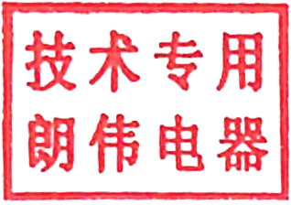

·Item | Description
Rated Voltage : | 220 VAC
Frequency: | 50/60Hz
Input Current: | 0.15/0.18A
Input Power: | 25/26W
Speed : | 2600/3000RPM ( ±10%）
Max.Air Flow :  ( at 0 Static Pressure) | 99/112 CFM
Max.Air Pressure :  ( at 0 Air Flow ) | 7.4/8.4 mm H2O
Acoustical Noise ( AVG.) : | 39/44 dBA
Insulation Type : | UL:CLASS A
Insulation Resistance : | Min. 100M ohm between frame and lead wire  at 500VDC/min
Dielectric Strength : | Max. 5mA between frame and lead wire  at 1800VAC for 1 sec
External Cover: | Open Type
Life Expectancy : | 50,000 Hours continuous operation at 40℃ with 0~90%RH
Rotation : | Clockwise view from name plate side
Lead Wire : | UL1007 22# ,Wire Length:300+/-10mm  PIN1: Black WIRE NEGATIVE (AC- )  PIN2: Red WIRE POSITIVE (AC +)

Characters :

Mechanical Data :

Environmental :
Dimensions : | See Dimensions Drawing ;
Frame : | Aluminium alloy ;
Impeller : | Plastic ;
Bearing Type : | Sleeve Bearing ;
Weight : | 460g

Operating Temperature : | -10 ℃ ~ +65 ℃ ;
Storage Temperature : | -15 ℃ ~ +65 ℃ ;
Operating Humidity: | 30 % RH ~ 95% RH ;
Storage Humidity : | 30 % RH ~ 95% RH ;

Drop Testing : | In minimum packaging condition : fan with stands each one drop of three faces from 30cm distance height onto 10mm thickness of wooden board ;
Locked Rotor Protection: | Impedance of Motor winding protects Motor from fire in 72 hours of locked rotor condition at the rated voltage ;
Production Location : | Made - In - China ;
Protection Type： | IP22

Protection :

Dimensions Drawing :

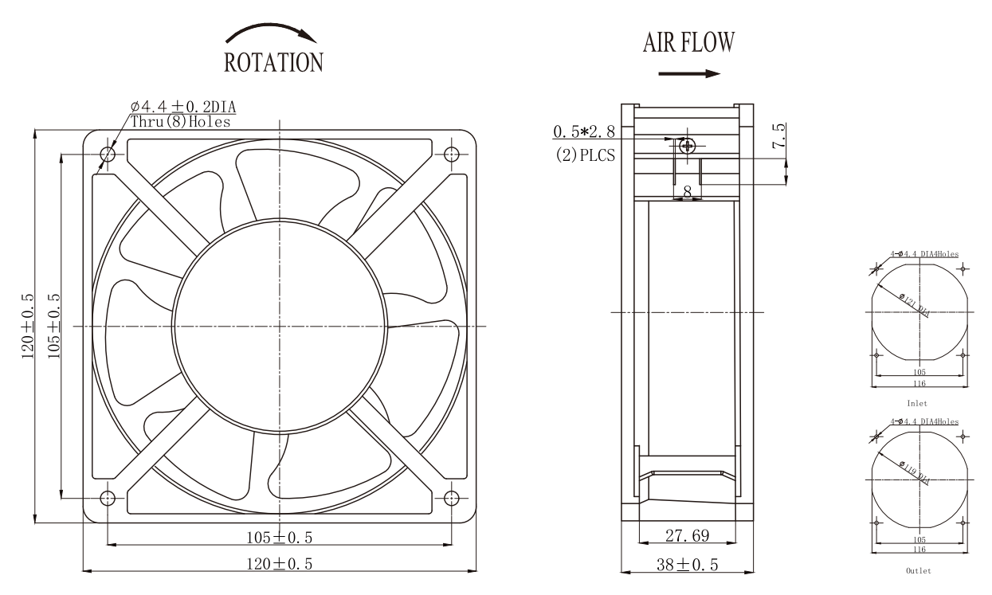

LABEL :

Confirm by sales team when placing sample order or bulk order
Notes :
UL1007 22# ,Wire Length:300+/-10mm
PIN1: Black WIRE NEGATIVE (AC- )
PIN2: Red WIRE POSITIVE (AC +)

Charts :Air Flow (P-Q)
:

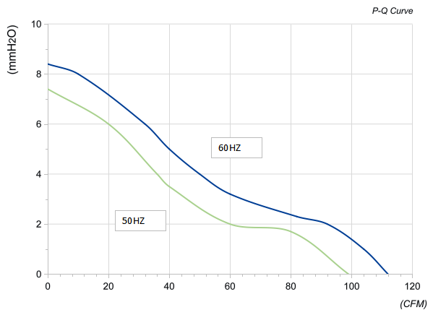
Warning:

1.The fan and motor must be used within the prescribed scope of temperature and humidity otherwise it will cause an unexpected damage.
2. Fan is not set wrong connection protection，Provide the right voltage and line sequence according to the nameplate otherwise it will damage the product.
3. Wiring depends on the wiring diagram and please connect the earth ground if required. We don't suggest to use the extension cord .Any wrong connection may cause the damage of the fan.
4. Be careful when moving the fan and do not take the blades as a handle because it will cause the distortion and chatter.
5. Connect the thermostat if required otherwise it would damage the motor because of the over temperature.
6. The length of the mounting screws shall not exceed the requirement, otherwise the fan will be damaged.
7. Do not disassemble the fan arbitrarily. It may hurt the capacity of water tightness and dynamic balance or cause other serious problems.
8. The over current protector is necessary in case the damage from the over current.
9. Install the fan as required, any other installing direction would affect the service life of the product.
10. The fan with inlet ring should be installed follow the requirements or it will affect the performance.
11. Users should use the standard cable when install the fan otherwise it will affect the water tightness.
12. The fan should keep away from the children especially the blade and electric parts .And the children are not allowed to operate the fan alone.
13. Do not connect the white signal cable directly to the red signal cable or the external DC power supply. Otherwise, the fan may be damaged.T
14.Please do not perform extraction and insertion of the connector under revolution irrespective of power on and power on and power off , and the fan should not touch or move when running.

15. Do not lift the fan wire when taking the fan, and do not impact the bearing during the handling process.
16. The version change may not be notified, please ask our company for the latest version when necessary.

17.Please be informed that we are not responsible for any damage or accidents caused by violating above rules to install and operate the fan.

Note :Please check and mark the data when you sign the specification sheet .
Approval
Product Data Confirm :
Speed Control System :

DATE :

CUSTOMER SIGNATURE:

CUSTOMER APPROVAL

