Ningbo Longwell Electric Technology CO.,LTD
NO.100, Ditang District ,Yuyao,Zhejiang Province,China 315400
Phone 86 574 6218 9863
Fax 86 574 6218 9863
sales@zjlongwell.com
www.longwellfans.com

Model No.: | LWAE3G630TS-5PKW-21-00
Version Number: | A0
Make : | Ye
Review : | Jiang
Approvd : | Yao
Date： | 20260609

Version number | Notes Remarks | Reason content | Revised by | Date



Nominal Data

Project1 | Unit | Rating
Nominal Voltage : | [VAC] | 400
Voltage Range : | [VAC] | 380~480
Frequency : | [Hz] | 50/60
Speed : | [rpm] | 1760
Current : | [A] | 3.95
Power input : | [W] | 2572
Air flow (Max) : | [m3/h] | 21169
Air flow (Max) : | [CFM] | 12453
Static pressure ( Max) : | [Pa] | 279
Noise level : | dB(A) | /
Max.ambient Temp : | ℃ | 65
Min.ambient Temp : | ℃ | -25
Insulation Class : |  | Class F
Protection Type : |  | IP54
Work system : |  | S1

Production Reference standard | GB12350《Safety requirements of small power motors》  JB/T10562 《 Technical specification for general purposes axial fans》  EN60335-1《Household and similar electrical appliances-safety》  ISO5801-1997《Industrial fans-performance testing using standardized airways》  GB/T2888《Methods of Noise Measurement for Fans Blowers Compressors and Roots Blowers》
Certification | CE
Environmental protection | RoHS、Reach

Technical Features

Technical Features

Service environment | Operating temperature：-25~65℃；Operating humidity：5 ~ 95 % RH  Storing temperature：-35 ~ 75℃；Storing humidity：5 ~ 95 % RH  Applicable altitude range：＜1000m
Life Expectance | 30,000Hours(L10)，At 40℃ room, humidity 15%~65%RH.
Balancing | According to JB/T 9101-1999 requirements G6.3
Vibration of the fan | Test method accord with JB/T 8689
Installation method | Horizontal or vertical installation
Material | Plastic( Impeller )
Bearing | Maintenance-free deep groove ball bearings
Weight | /

Electrical Protection

Speed Control | Control input 0~10VDC/PWM/RS485/4-20mA
VSP Control | Control signal VSP voltage range0±0.2VDC~10±0.2VDC  (During normal operation, when the VSP voltage is below 1.0±0.1VDC, the motor switches from operating mode to standby mode)
PWM Control | PWM signal: frequency 0.1K～1KHz, amplitude 10～12V,duty cycle 0%～100% .
Signal Output | Tach output：12 Pulse/R；FG internal open circuit output, external pull-up resistor R, pull-up voltage V.
Auxiliary power output | Output 10VDC，Max Current 20 mA
Protection | Over-temperature protection、Over-current protection、Locked-rotor protection’
Soft start | Delay time <30 seconds to full speed
Serial Communication | LWRS485-05

Product Drawing

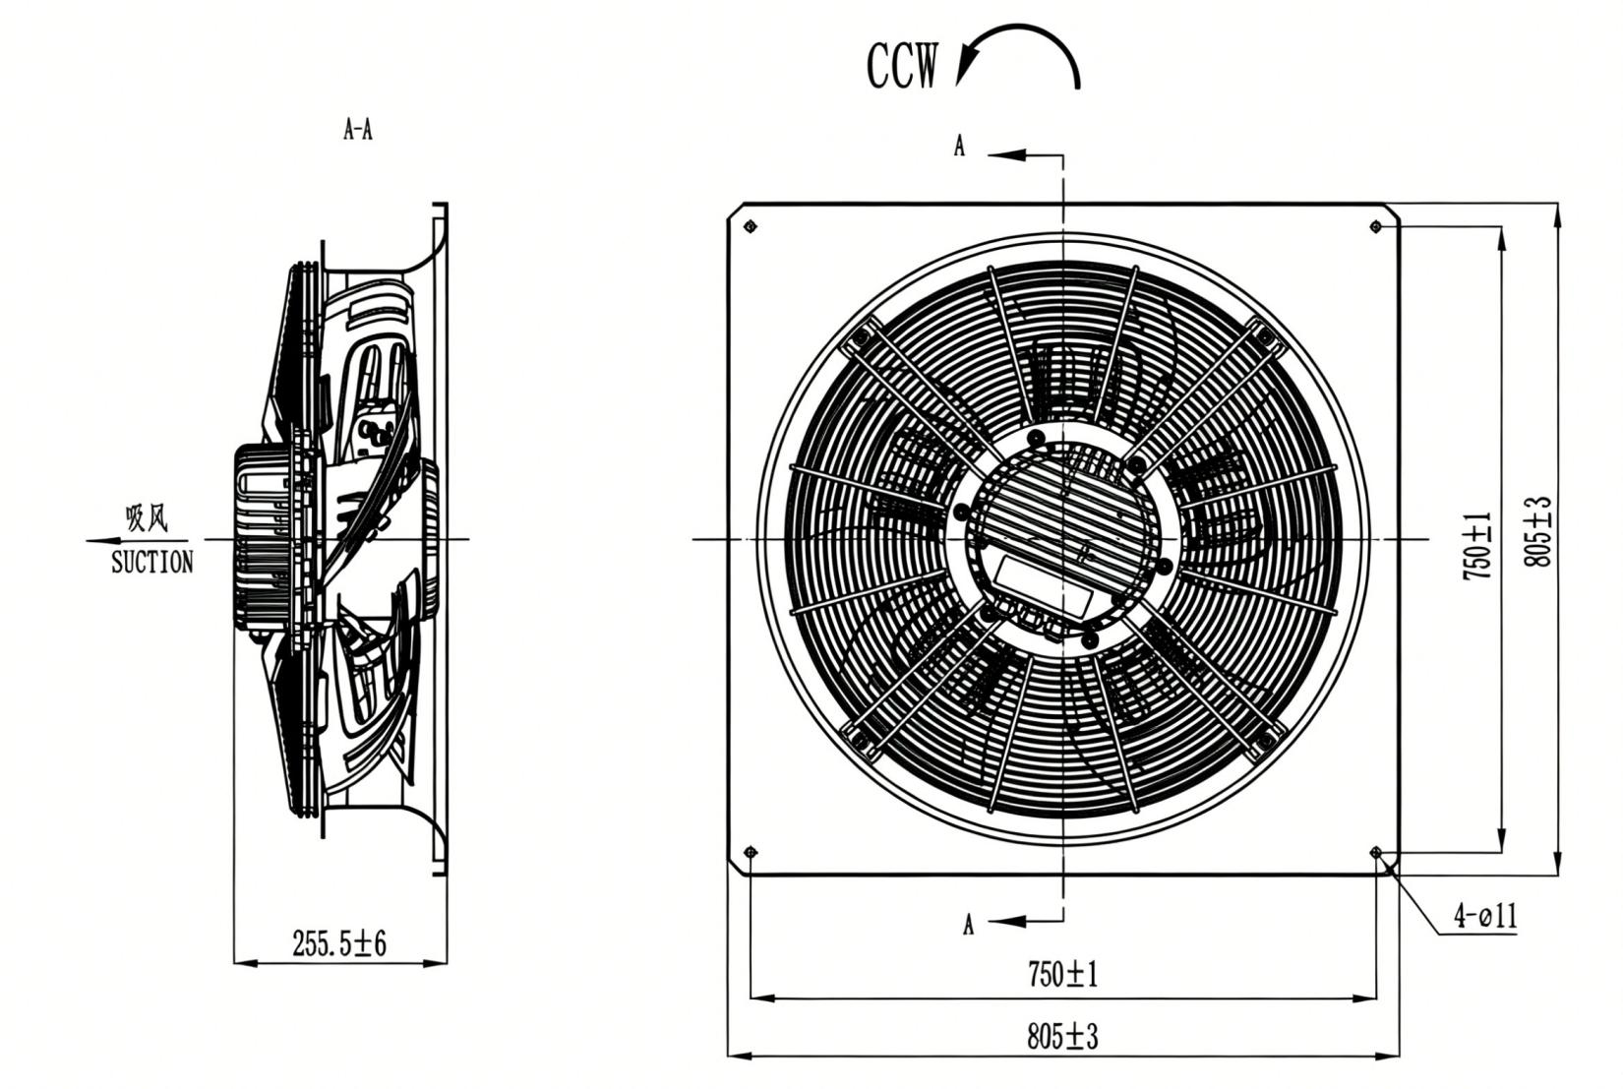

Wiring Diagram

P3 |  |  |  |  |  |  |  |  |  |  |  | P2 |  |  | P1 |  |  |  |  | PE
RSA | RSB | RSA | RSB | GND | Ainl U | 4~20mA | 20V | 10V | Dinl | GND | FG | NC | COM | NO | L3 |  | L2 |  | L1 | PE
NO. | Signal信号 | Assignment/Function分配/功能 | NO. | Signal信号 | Assignment/Function分配/功能
PE | PE | Protect earthing,ground  接地线，PE线 | P3 | RSA | Bus RS485; RSA;MODBUS RTURS485总线连接;RSA;MODBUS通讯协议RTU方式
P1 | L3 | AC power in, voltage input 3~380-480V;50/60Hz交流电输入，供给电压3~380-480V;50/60Hz | P3 | RSB | Bus RS485;RSB;MODBUS RTURS485总线连接;RSB;MODBUS通讯协议RTU方式
 |  |  |  | GND | interface P3 for signal control,ground接口P3控制信号地线
P1 | L2 | AC power in,voltage input 3~380-480V;50/60Hz交流电输入，供给电压3~380-480V;50/60Hz | P3 | Ainl U | Controler input0~10VDC/PWM控制输入0~10VDC/PWM
 |  |  |  | 4~20mA | Analogue Control input 4~20mA/ 控制输入4~20mA
 |  |  |  | 20V | Rated voltage output 20VDC (I10% max. 50mA)固定电压输出20VDC(士10% max.50mA)
P1 | L1 | AC power in,voltage input 3~380-480V;50/60Hz交流电输入，供给电压3~380-480V;50/60Hz | P3 | 10V | Rated voltage output 10VDC (士10% max. 10mA)固定电压输出10VDC(士10% max.10mA)
P2 | NO | State relay,alterable state contact;normally turn-on;turn-off when error  状态继电器，浮动状态触点;常开;关闭错误 | P3 | FG | Speed Signal Feedfack/速度反馈信号
 |  |  |  | Dinl | Connection of Digital input 1 enabling of  electronics enabling:/数字式输入端1电子设备的接通;
P2 | COM | State relay,universal connectivity;contact rating 250VAC/2A  状态继电器，公共连接;连接等级250VAC/2A | P3 | Dinl | opening pin or applied voltage 5-50V DC;接通:管脚为开路或者所施加的电压为5到50VDC;
P2 | NC | State relay,normally turn-off;turn-on when  error;状态继电器，常闭;接触错误 | P3 | Dinl | disabling: bridge to GND or applied voltage<lV DC截止:接地桥接或者所施加的电压<1VDC.

Label

Label

Confirm by sales team when placing sample order or bulk order

Charts :Air Flow (P-Q)

电流≦ mA不能用于***，上电顺序要求

Confirm by sales team when placing sample order or bulk order
Label
Current  （A） | Speed  (RPM) | Power input  (W) | Airflow  (m³/h) | Static pressure  (Pa)
3.95 | 1760 | 2572 | 21169 | 0
4.14 | 1760 | 2684 | 19445 | 93
4.35 | 1760 | 2803 | 17228 | 186
4.46 | 1760 | 2894 | 14418 | 271

Warning:

1.The fan and motor must be used within the prescribed scope of temperature and humidity otherwise it will cause an unexpected damage.
2. Fan is not set wrong connection protection，Provide the right voltage and line sequence according to the nameplate otherwise it will damage the product.
3. Wiring depends on the wiring diagram and please connect the earth ground if required. We don't suggest to use the extension cord .Any wrong connection may cause the damage of the fan.
4. Be careful when moving the fan and do not take the blades as a handle because it will cause the distortion and chatter.
5. Connect the thermostat if required otherwise it would damage the motor because of the over temperature.
6. The length of the mounting screws shall not exceed the requirement, otherwise the fan will be damaged.
7. Do not disassemble the fan arbitrarily. It may hurt the capacity of water tightness and dynamic balance or cause other serious problems.
8. The over current protector is necessary in case the damage from the over current.
9. Install the fan as required, any other installing direction would affect the service life of the product.
10. The fan with inlet ring should be installed follow the requirements or it will affect the performance.
11. Users should use the standard cable when install the fan otherwise it will affect the water tightness.
12. The fan should keep away from the children especially the blade and electric parts .And the children are not allowed to operate the fan alone.
13. Do not connect the white signal cable directly to the red signal cable or the external DC power supply. Otherwise, the fan may be damaged.T
14.Please do not perform extraction and insertion of the connector under revolution irrespective of power on and power on and power off , and the fan should not touch or move when running.

15. Do not lift the fan wire when taking the fan, and do not impact the bearing during the handling process.
16. The version change may not be notified, please ask our company for the latest version when necessary.

17.Please be informed that we are not responsible for any damage or accidents caused by violating above rules to install and operate the fan.

Note :Please check and mark the data when you sign the specification sheet .
Approval
Product Data Confirm :
0-10V
PWM
Speed Control System :

DATE :

CUSTOMER SIGNATURE:

CUSTOMER APPROVAL

