1
FG4K500-4APL-30
AC Axial Fan

1、一般技术参数 Nominal Date
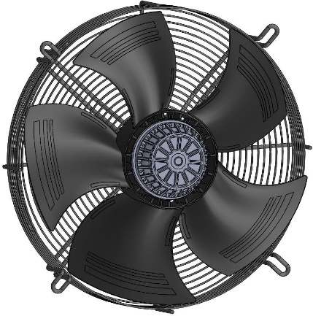
轴流风机
AC Axial fan
型号 Type | FG4K500-4APL-30
电机类型 Model | AC137

相 Phase | ~ | 3~
额定电压 Nominal Voltage | VAC | 380
电压范围 Nominal voltage range | VAC | 342~418
频率 Frequency | Hz | 50/60
电流消 Current draw | A | 1.5/1.8±10%
转速 Speed(RPM) | min-1 | 1350/1550±5%
功率消 Power consumption | W | 750/1000±10%
声压级 Sound Pressure Level | dB(A） | 80/82±5%
最大风量 Max. Air Flow | m3/H | 9000/11000
绝缘等级 Insulation class | ~ | Class F
防护等级 Degree of protection | ~ | IP54

2
FG4K500-4APL-30
AC Axial Fan

2、电气性能 Electrical Characteristics
使用温度范围 Operating Temperature | -25℃ to 60℃
储存温度 Storage Temperature | -40℃ to 75℃
工作湿度 Operating Humidity | 5% to 90% RH
储存湿度 Storage Humidity | 5% to 95% RH
热保护器 Thermal Protection | 断开温度: 150-160℃;复位温度: 100-130℃  Cut off temperature: 150-160℃; replacement temperature: 100-130℃
寿命 Life Expectance | 在 40℃的室内，湿度 15%~65%RH 环境下寿命  30000 小时(L10)  30,000 Hours(L10)，At 40℃ room, humidity 15%~65%RH
风轮直径 Impeller Diameter | 500mm
叶片数量 Number of Blades | 5
叶轮材料 Impeller Material | 塑料+玻纤 Propylene with glass-fiber reinforced
叶轮旋转方向  Direction of Rotation | 逆时针方向，转子看向端盖  Anti-clockwise, viewed toward rotor
安装位置  Installation position | 任意方向 Any
电机轴承 Motor bearing | 滚珠轴承 Ball bearing
转子表面 Surface of Rotor | 电泳黑色 Coated in black
标准/证书 Valid For Approval/Standard | RoHS

3
FG4K500-4APL-30
AC Axial Fan

3、风机图纸 Product drawing
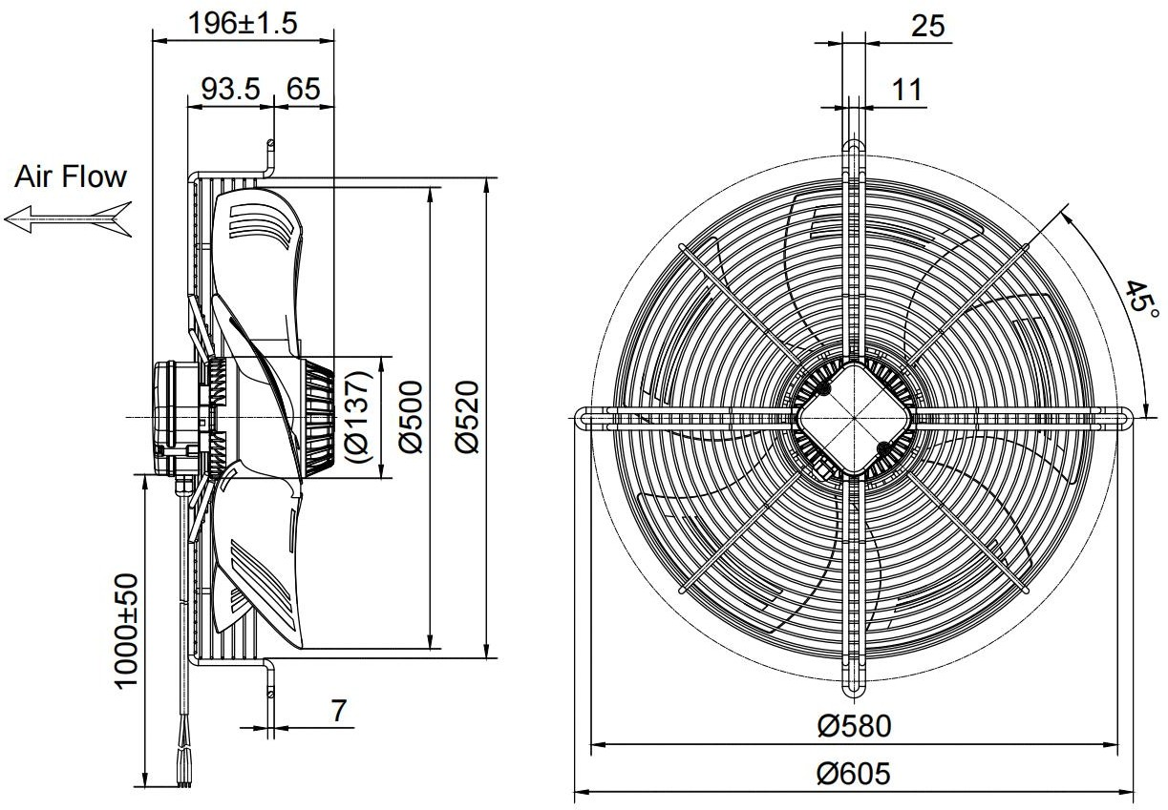
4、接线图 Connection diagram

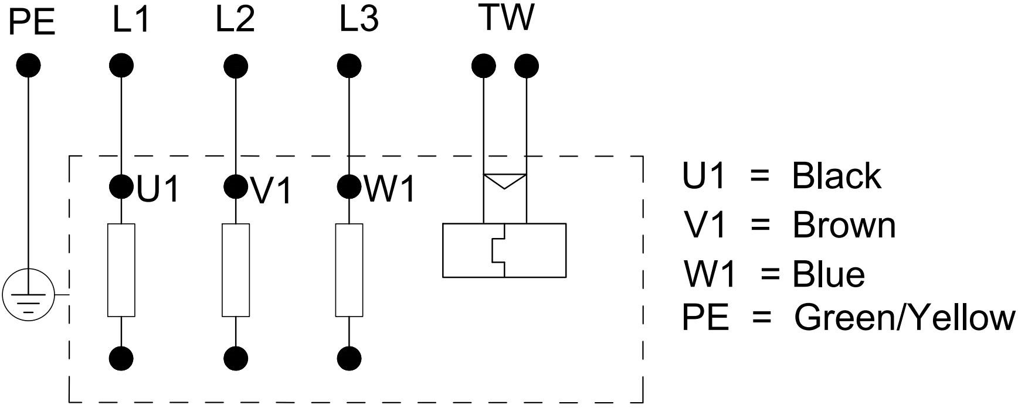

FG4K500-4APL-30
AC Axial Fan

5、风量静压曲线图 Aerodynamic Performance Charts
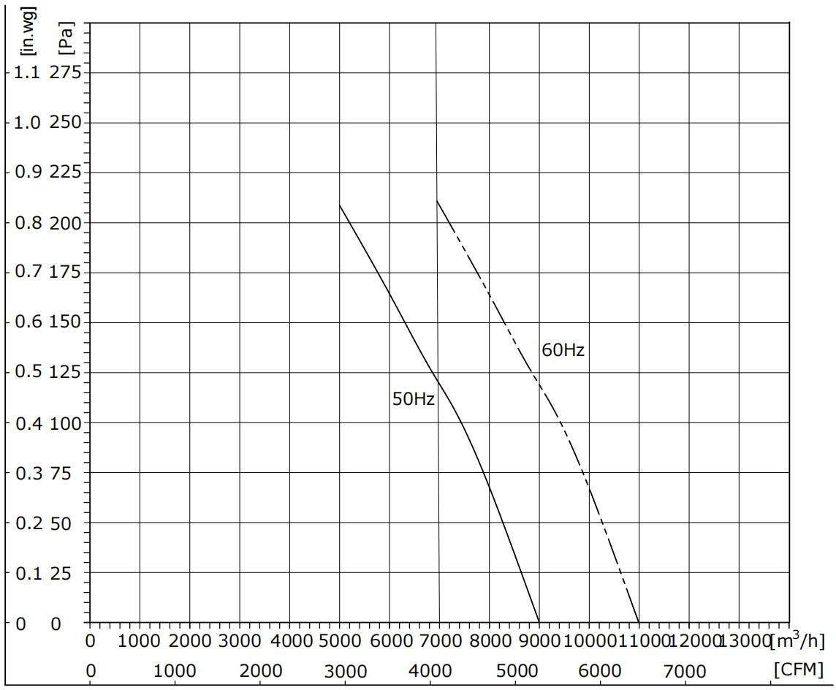

测试条件 Test condition：
Ⅰ.测试数据是在规定的环境条件和安装方式下获得的
Ⅰ.The test data is obtained under the specified environment conditions and installation mode
Ⅱ.输入电压---工作电压
Ⅱ.Input Voltage---Operating voltage
Ⅲ.温度---室温
Ⅲ.Temperature---Room temperature
Ⅴ.湿度---65%RH
Ⅴ.Humidity---65%RH
4

FG4K500-4APL-30
AC Axial Fan

6、安全使用说明 Safety Requirements
- 取出风机时，请勿直接提起风机引线。如果引线受力过大，内部焊接部分可能会脱落。 1.When taking out the fan, do not directly lift the fan lead. If the lead is excessively stressed, the internal welding part may fall off。
- 禁止在风机运行时拔插风机引线插头。
- Do not plug or unplug the fan lead plug when the fan is running。
- 如果风机启动后不工作，请勿触摸叶轮、转子等部件，请专业技术人员对风机进行检查，防止风机突然启动造成手部或其他人身伤害。
- If the fan does not work after starting, do not touch the impeller, rotor, or other parts, professional technical personnel are required to inspect the fan to prevent sudden start of the fan from causing hand or other personal injury.
- 由于风机为软启动特性，在上电或低速运行时，请勿触摸风机叶轮或其他部件，以免造成
人身伤害。
- Because of the soft start characteristics of the fan, to prevent personal injury, do not touch the impeller or other parts of the fan during powered on or running at low speeds.
- 风机需要在专业人员指导下操作和使用，防止儿童接触到本产品。
- The fan needs to be operated and used under the guidance of professional personnel to prevent children from coming into contact with this product.
- 电源线如有磨损或损坏，需回厂维修或在厂家指导下更换。
- If the power cord is worn or damaged, it needs to be returned to the factory for repair or be replaced under the guidance of the manufacturer.
- 电机作为风机的一部分，在没有叶轮或负载的情况下，不建议单独使用。
- As a part of the fan, it is not recommended to use the motor alone when there is no impeller or load.
- 使用前请仔细阅读本技术手册。

8.Please read this technical manual carefully before using it.
5

